SIMATS ENGINEERING
ASSESSMENT TOOL 2

COURSE NAME: Database Management Systems
COURSE CODE: CSA05

COURSE OUTCOME COVERED
CO2: Apply the relational model, relational algebra, SQL query structures, and views
to solve database querying and data manipulation problems. (BL3, BL6)
Activity Tool : Analytical Problem Solving (High)
Assessment Tool Weightage: 35%

Code of Conduct:
I SUVATHI.S(192571064) (Name / Reg No) certify that this submission is my
original work and that I have adhered to the guidelines specified for this assessment.
I understand that any violation of academic integrity rules will result in disciplinary
action.
Signature of the student:SUVATHI.S
ANALYTICAL QUESTION
1.Given the scenario of a School Management System, identify
relations and write SQL to list all students with their class teacher
and grade.

Relations

STUDENT(Student_ID, Student_Name, Class_ID, Grade)

CLASS(Class_ID, Class_Name, Teacher_ID)

TEACHER(Teacher_ID, Teacher_Name)
SQL QUERIES AND OUTPUT:
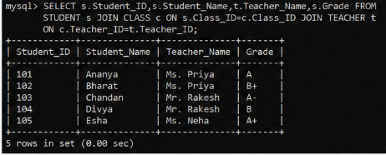
2. A hospital wants to track patient appointments. Design the relational
schema and write SQL to find doctors with more than 10
appointments this month.
Relational Schema
- DOCTOR(Doctor_ID, Doctor_Name, Specialization)
- PATIENT(Patient_ID, Patient_Name)
- APPOINTMENT(Appointment_ID, Doctor_ID, Patient_ID, Appointment_Date)
SQL QUERIES AND OUTPUT:
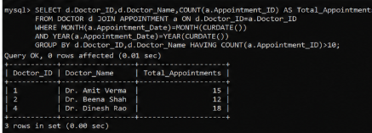

3.In an e-commerce scenario, write SQL queries using sub-queries toind products that have never been ordered.
Tables
- PRODUCT(Product_ID, Product_Name)
- ORDER_DETAILS(Order_ID, Product_ID)
SQL QUERIES AND OUTPUT:
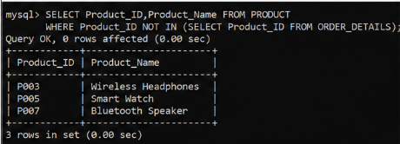
4.For a university database, write relational algebra expressions to
find students enrolled in both “DBMS” and “OS”; courses.
Relations
DBMS ← σCourse_Name='DBMS'(COURSE)
OS ← σCourse_Name='OS'(COURSE)
DBMS_STUDENTS ← πStudent_ID
(ENROLLMENT ⋈ DBMS)
OS_STUDENTS ← πStudent_ID
(ENROLLMENT ⋈ OS)
RESULT ← DBMS_STUDENTS ∩ OS_STUDENTS
5.Given a payroll scenario, create a view showing employees whose
salary is below department average and write a query to update
their salary by 10%.
Table
EMPLOYEE(Emp_ID, Emp_Name, Dept_ID, Salary)
SQL QUERIES AND OUTPUT:
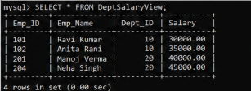
6.In a banking scenario, apply JOIN operations to retrieve customer
account details, transaction history, and branch information.
Tables
- CUSTOMER(Customer_ID, Customer_Name)
- ACCOUNT(Account_No, Customer_ID, Branch_ID)
- TRANSACTION(Transaction_ID, Account_No, Amount)
- BRANCH(Branch_ID, Branch_Name)
SQL QUERIES AND OUTPUT:
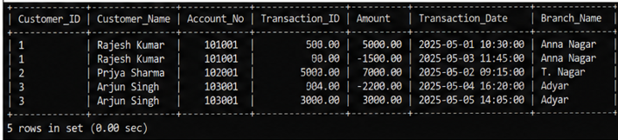
7 A retail store needs daily sales summary. Write SQL with GROUP
BY and HAVING to report total sales per category exceeding Rs.
10,000.
Table
- SALES(Sale_ID, Category, Amount)
SQL QUERIES AND OUTPUT:
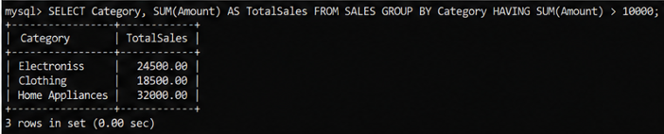
8.For a library system scenario, construct tuple relational calculus
expressions to find members who borrowed books from all genres.
Relations
- MEMBER(Member_ID, Member_Name)
- BOOK(Book_ID, Genre)
- BORROW(Member_ID, Book_ID)

Tuple Relational Calculus Expression
{
m.Member_Name |MEMBER(m)
AND
EXISTS b (BORROW(b) AND b.Member_ID = m.Member_ID)
}
9.Given an inventory management scenario, define CHECK and
FOREIGN KEY constraints and demonstrate their enforcement
through SQL.
Table
Product(product_id,product_name,price,supplier_id)
SQL QUERIES AND OUTPUT:
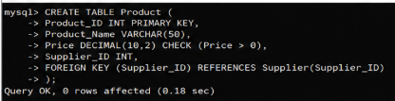

10.Design a relational schema for an HR system and create
materialized views for monthly attendance and performance
summaries.
Relational Schema
EMPLOYEE(Emp_ID,Emp_Name,Dept_ID)
DEPARTMENT(Dept_ID,Dept_Name)
ATTENDANCE(Attendance_ID,Emp_ID,Attendance_Date,Status)
PERFORMANCE(Performance_ID,Emp_ID,Month,Rating)
SQL QUERIES AND OUTPUT:
